Navy League of the United States

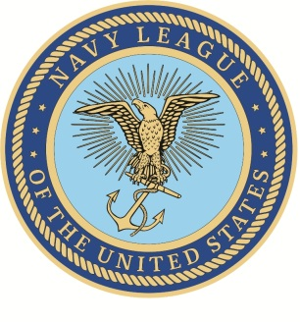
_______________________ Council

Certificate of Recognition

The _______________________________ Council of the Navy League of the United States takes pleasure in recognizing ____________________________________ for superior service in our adopted Sea Service unit, ______________________________.
_______________________________ set a strong positive example for others to follow by _________________________ ______________________________________________________.
____________________________'s outstanding achievement demonstrated only the highest degree of initiative, drive, and dedication. Their strong personal commitment to their professional duties contributed significantly to their command's important mission in support of national security, and were in keeping with the highest traditions of our nation's Sea Services.
Given this _______ day of ____________________, 20_______
Signed:

________________________________
President
_____________________________________ Council
Navy League of the United States

