Navy League of the United States

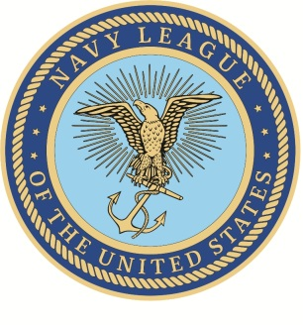
Certificate of Adoption

WHEREAS, The Navy League of the United States is the foremost citizens’ organization to serve, support, and stand with all the Sea Services – the U.S. Navy, U.S. Marine Corps, U.S. Coast Guard and U.S.-flagged Merchant Marine; and
WHEREAS, We believe that the security of our nation and of the people of the world requires a well-balanced American defense team which includes strong sea services; and
WHEREAS, To promote the rapport and understanding between the Navy League of the United States and the Sea Services, as well as enhance the well-being of Sea Service members and their families, we, the ___________________________ Council of the Navy League of the United States, as our personal responsibility to enhance the above-mentioned rapport and understanding, desire to adopt ________________________.
THEREFORE, We, members of the ______________________________ Council of the Navy League of the United States, by the authority granted to our President and with full knowledge of the ________________________ of ________________________________________________________; do
HEREBY adopt_____________________________________________.
Executed this _______ day of ____________________, 20_______
Signed by the ______________________________________ Council:

_____________________________ ________________________
President Council Adopted Unit Liaison

Acknowledged by ___________________________________________:

____________________________________________
Commanding Officer/Commander /Officer-in-Charge

